Title of the abstract

(Arial, 12 pt, bold, sentence case, single spaced, centered)

First A. AUTHORa, Second B. AUTHORb, ...

(Arial, 11 pt, single spaced, centered) Presenting author underlined

*aAffiliation of the First A. Author*

*bAffiliation of the Second B. Author (Arial, 11 pt, single spaced, centered)*

*Email of corresponding author: Arial, 11 pt, italics.*

Start writing the Main text here … Main text: Arial, 11 pt, single spaced, justify

The references should be cited in the text in square brackets, and the reference should be added after the text using the format below [1].

Figures may be included in the text. They should be cited in the text (**Fig. x**).

Each figure should have a caption in Arial, 11 pt, single spaced, centered.

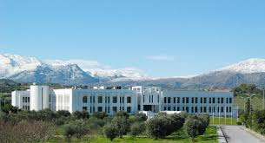

Fig. 1. IESL – FORTH, Heraklion.

Documents should not be longer than one A4 page (210mm wide x 297mm high)

Acknowledgments. (Arial, 11 pt, single spaced)

[1] X. Surname, Y. Surname, *J. Am. Chem. Soc.* **Year**, *volume*, page. (Arial, 10 pt, single spaced)

[2] X. Surname, Y. Surname, *J. Am. Chem. Soc.* **Year**, *volume*, page. (Arial, 10 pt, single spaced)

Please send the document to *dodynet-manager@uclouvain.be*